**GIT-HOL ASSIGNMENT-2** (1 page)

**What is .gitignore?**  
The .gitignore file is a special text file that tells Git which files or directories to ignore when committing changes to the repository. It is useful for excluding files that are not relevant to the project’s source code, such as temporary files, build output, logs, or environment-specific configurations.

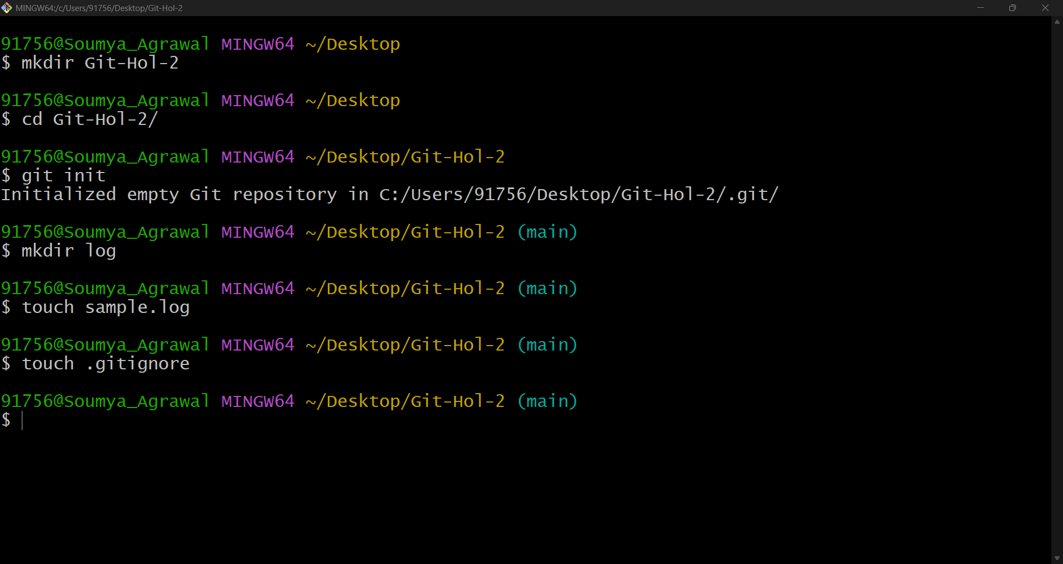

**Figure1: Initialising local git repository and creating required files and folders to ignore for commit.**

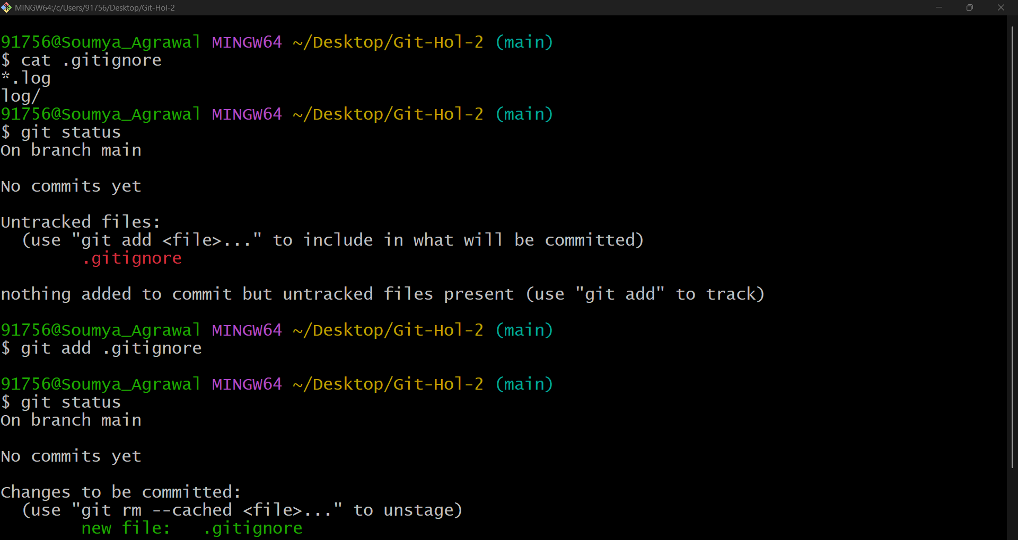

**Figure 2: Adding files and folders in .gitignore and git status not showing the same files and folders eligible for committing.**